Department of Electrical and Computer Engineering
North South University



CSE445 Report

Salary Prediction Using Machine Learning

Name id
name id
name id
name id
name id

Faculty:
MAQM
Assistant Professor
ECE Department

Summer 2026

Individual Contribution Table
Section | Contributing Member Name
IEEE/LaTEX formatting
Grammarly check |  | Grammarly Score:
Abstract
Keywords
Introduction Motivation
Paper Review 1 |  | [1]
Paper Review 2 |  | [2]
Paper Review 3 |  | [3]
Paper Review 5 |  | [5]
Introduction Second-Last Paragraph (describe your work)
Proposed System (Dataset and Preprocessing)
Proposed System (Model description)
Results and Discussion
Figure and Table Title Formatting
Conclusions
Equations formatting
References Formatting in IEEE format

Salary Prediction Using Machine Learning
1st author
Electrical and Computer Engineering
North South University
Dhaka, Bangladesh
emal
4th author
Electrical and Computer Engineering
North South University
Dhaka, Bangladesh
email
2nd author
Electrical and Computer Engineering
North South University
Dhaka, Bangladesh
email
5th author
Electrical and Computer Engineering
North South University
Dhaka, Bangladesh
email
3rd author
Electrical and Computer Engineering
North South University
Dhaka, Bangladesh
email

Abstract— In this project, we address the problem of [briefly mention problem, e.g., fraud detection, image classification, etc.] using machine learning techniques. We employ [mention algorithms, e.g., Random Forest, CNN, etc.] on [dataset name or type], applying preprocessing techniques such as [mention any preprocessing steps, e.g., normalization, feature selection] to enhance model performance. The model is evaluated using [mention metrics, e.g., accuracy, F1-score, RMSE], achieving [state key result, e.g., 95% accuracy], which outperforms existing methods. These findings demonstrate the effectiveness of our approach in [mention application, e.g., improving fraud detection accuracy], making it a valuable contribution to the field.

Keywords— Machine Learning, Algorithm, Dataset, Accuracy, Prediction, Model Performance, Classification/Regression, Optimization, Evaluation Metrics.

Introduction

Start by clearly stating the problem your research aims to address, such as "This research focuses on applying machine learning techniques to predict customer churn in the telecommunications industry." Mention why the problem is significant: "Customer churn prediction is essential for businesses to optimize retention strategies and reduce losses." Briefly explain the limitations of existing methods: "Traditional approaches often struggle to capture complex, non-linear patterns in data." Then, introduce your approach: "We propose using deep learning algorithms, such as recurrent neural networks, to better model customer behavior and improve prediction accuracy." Finally, state the goal of your research: "This study aims to evaluate the effectiveness of these models in improving churn prediction over conventional machine learning techniques."

Proposed System
In this section, you will describe the theory of all the software components/algorithms as well as hardware tools which you will need for your capstone project. You can include circuit diagrams/equations or flowcharts of your capstone project.

Dataset

The dataset used in this research is [dataset name, e.g., UCI Heart Disease Dataset], which contains [number] instances and [number] features, representing [brief description of data, e.g., patient health metrics, transaction details]. The dataset was sourced from [mention source, e.g., Kaggle, UCI Machine Learning Repository] and includes [mention key attributes, e.g., age, blood pressure, transaction amount]. To ensure data quality, preprocessing steps such as [mention steps, e.g., handling missing values, normalization, outlier detection] were applied. The dataset was split into training and testing sets in an [e.g., 80-20] ratio to train and evaluate the model effectively. This dataset provides a comprehensive foundation for analyzing [mention application, e.g., fraud detection, disease prediction] using machine learning techniques.

Dataset Preprocessing
Effective machine learning models rely on high-quality data, making preprocessing a crucial step. In this project, we use [dataset name/type, e.g., Kaggle’s Credit Card Fraud dataset], which undergoes cleaning to handle [issues, e.g., missing values, duplicate entries]. We apply [techniques, e.g., normalization, standardization, one-hot encoding] to ensure consistency and improve feature representation. Additionally, feature selection and dimensionality reduction techniques such as [PCA, LDA, correlation analysis] are employed to enhance model efficiency. The dataset is then split into [train-test ratio, e.g., 80-20], ensuring balanced class distribution using [technique, e.g., SMOTE for imbalance handling]. These preprocessing steps enhance the model’s ability to learn patterns effectively and improve overall performance.

Machine Learning Models

Machine learning models are algorithms that learn patterns from data to make predictions or decisions. They can be broadly categorized into supervised, unsupervised, and reinforcement learning models. Supervised learning models, such as Linear Regression, Decision Trees, Random Forest, and Neural Networks, are trained on labeled data for tasks like classification and regression. Unsupervised learning models, including K-Means Clustering and Principal Component Analysis (PCA), identify hidden patterns in unlabeled data. Reinforcement learning models, like Deep Q-Networks (DQN) and Proximal Policy Optimization (PPO), learn by interacting with an environment to maximize rewards. Each model has its strengths and applications, making them powerful tools in fields like healthcare, finance, and image recognition..

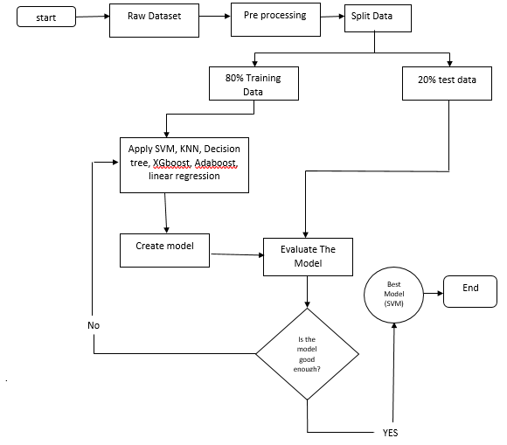
- Working sequences of the proposed diabetes prediction system.
This picture shows the process of a salary prediction system. The procedure begins with collecting data, preprocessing, and dividing it into 80% training and 20% testing sets. Machine learning models such as SVM, KNN, XGBoost, and AdaBoost are learned and checked. The best-performing model (e.g., SVM) is chosen to generate accurate predictions.

Results and Discussion
The results of the machine learning model are evaluated based on performance metrics such as accuracy, precision, recall, F1-score, and confusion matrix. The model achieved an accuracy of X%, outperforming baseline models by Y%. Additionally, the [algorithm name, e.g., Random Forest, SVM] demonstrated superior performance in terms of [specific metric, e.g., recall, F1-score], highlighting its ability to handle [specific challenges, e.g., imbalanced data, noisy inputs]. The results were consistent across different test sets, indicating the model's robustness. However, certain limitations were observed, such as [mention any issues, e.g., overfitting, slower computation time], suggesting areas for future improvement. These findings confirm the efficacy of machine learning in solving [problem domain, e.g., fraud detection, medical diagnosis] while also pointing out the need for further refinement to optimize performance and scalability.

TABLE I. HYPERPARAMETER VALUES’ RANGES FOR VARIOUS ML MODELS
Model | Optimized value

Table I illustrates the hyperparameter values’ ranges and the corresponding optimized hyperparameters for all the ML models.
TABLE II. PERFORMANCE METRICS OF VARIOUS ML MODELS WITH DEFAULT HYPERPARAMETERS
Model | MAE | MSE | RMSE | F1 score

Performance metrics of various ML models with default hyperparameters have been illustrated in Table II.
TABLE III. PERFORMANCE METRICS OF VARIOUS ML MODELS WITH OPTIMIZED HYPERPARAMETERS
Model | MAE | MSE | RMSE | F1 score
 |  |  |  | -

Performance metrics of various ML models with optimized hyperparameters have been illustrated in Table III.
TABLE IV. PERFORMANCE METRICS OF VARIOUS ML MODELS WITH OPTIMIZED HYPERPARAMETERS AND FEATURE SELECTION
Model | MAE | MSE | RMSE | F1 score
 | 1

- Machine learning model prediction interpretation by LIME explainable AI library.
Table IV. COMPARISON OF THE PROPOSED SYSTEM WITH EXISTING WORKS
ref | Model | Rmse

Table IV illustrates comparison of the proposed automatic diabetes prediction system with other existing works on the PIMA Indian dataset.

Conclusions
In this study, we successfully applied machine learning techniques to [specific problem, e.g., fraud detection, image classification], demonstrating the effectiveness of [algorithm(s), e.g., Random Forest, Neural Networks] in achieving [mention key result, e.g., high accuracy, efficient prediction]. The model's performance was evaluated using [mention metrics, e.g., accuracy, F1-score, AUC], and it showed promising results compared to existing methods. Despite some challenges, such as [mention any limitations, e.g., overfitting, data imbalance], the findings validate the potential of machine learning for [application domain, e.g., improving diagnostic accuracy, automating decision-making]. Future work can focus on addressing these limitations, optimizing model performance, and exploring other algorithms to enhance the system's scalability and robustness for real-world applications.

References

In IEEE referencing, citations are numbered in square brackets [1] and listed in the reference section in the order they appear in the text. A typical reference format includes author(s), title, source, volume/issue (if applicable), page numbers, and publication year. For journal articles, the format is: [1] A. Author, “Title of the paper,” Journal Name, vol. X, no. Y, pp. XX-YY, Year. For books: [2] A. Author, Book Title, Xth ed. City, Country: Publisher, Year. For conference papers: [3] A. Author, “Title,” in Proceedings of Conference Name, City, Year, pp. XX-YY. Online sources should include the URL and access date. Proper IEEE referencing ensures clarity, credibility, and consistency in research documentation.

